Bahrain Family Readiness Group

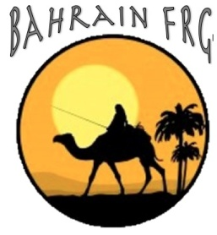

E-Membership Form

Instructions:

|  |  |
| --- | --- |
| 1) Download form to your computer | 3) Save form to your computer |
| 2) Type in your information | 4) Email completed form to BahrainFRG@gmail.com |

PERSONAL INFO

|  |  |
| --- | --- |
| Member Name: | Sponsor’s Name: |
| Phone: | Sponsor’s Command: |
| Email: | Projected Rotation Date: |
| Children Residing in Bahrain (Y/N): | Ages: |

**How did you find out about the Bahrain Family Readiness Group? (check one)**

🞎 Facebook 🞎 Desert Times 🞎 Flyer on base 🞎 Radio Ad 🞎 Friend 🞎 Other (describe) __________

I allow the Bahrain FRG to publish pictures that include myself and/or my family members participating in Bahrain FRG events for the purpose of promoting the BFRG in a social manner (Y or N) _____

I allow the Bahrain FRG to share my information with other members of this group (Y or N) _____

I allow the Bahrain FRG to invite me to join our closed Facebook group for updates on events and base-related information. (Y or N) _____

Please type your name after ////signed////

Signature: ////signed////

Date:

VOLUNTEER OPPORTUNITIES

**PLEASE NOTE IF YOU WOULD LIKE TO VOLUNTEER IN ANY OF OUR COMMITTEES:**

___**Welcoming/Hospitality:** Do you like to be the first person to greet new people on the island? Are you the gal/guy who likes to reach out to the new person and take them under your wing? Do you like to chat? Well, put your skills to use for us! We welcome you!!

___**Events:** Do you have a creative side? Do you like planning parties and fun new things that you can share with your friends while meeting new friends? If so, this is the place for you! We love to explore new interests & fun activities within our community! Sign up here!

___**Communications:** Calling all previous high school editors! Do you like graphic design? Are you a grammar queen/king? Help us spread the word about the BFRG news & upcoming activities in the area. You would be a great asset to those families who need to be in the know!

Form Revised: 07 May 2015